***PEYTON CARNEY***

***IMAD 5112 A1***

***THE AGE HISTORY MATCHER APPLICATION***

***09.04.2024***

Lord Acton once said, “History is not a burden on the memory but an illumination of the soul.” Gaining knowledge about history and the lives of famous people might help one develop essential insights into what it is like to be human. Nevertheless, for contemporary audiences, conventional approaches to teaching history can occasionally seem disjointed or uninteresting. By providing users with a personalized and interactive approach to investigate historical people and their ages at the time of their deaths, the “Age History Matcher” app seeks to close this gap. This study highlights the importance of the “Age History Matcher” app as a tool for historical discovery and teaching in the digital age by giving a general overview of the app's goals, design, implementations, and possible effects.

The “Age History Matcher” app's main goal is to give users a fun and instructive experience based on historical personalities. Users are encouraged to connect their own lives with those of historical characters by entering their age and learning which historical personalities died at a similar age. This individualized method of teaching history promotes inquiry, discovery, and a greater understanding of the topic. The application promotes dynamic and customized user interaction with historical material. Users may better grasp various historical periods, events, and cultural situations by making connections between historical characters and themselves. Using the matching capability, users may establish an aura of connectivity and contrast across various eras by comparing their age with that of historical individuals. Implementing this comparison approach may allow users to consider where they fit into history and see how different human experiences have been (*Educational apps for history lessons* 2022).

To achieve its instructional goals, the "Age History Matcher" app integrates several essential features and functionalities. To make the app user-friendly, it has a straightforward and user-friendly design. The primary interface consists of an age entry field, a button to commence the matching procedure, a text view showcasing the corresponding historical data, and a clear button to reverse the input and outcomes. The program has an easy-to-use interface with an input field for the user's age, a button to start the age-matching process, a text view to show the results, and a clear button to reset the input and results. The "Match" option allows visitors to input their age and see a list of historical persons who died at the same age. To ensure that only entire integers between 20 and 100 are allowed, the program handles input errors. The software finds historical persons who died at the designated age and shows them in the result area when the match button is clicked. A pop-up noting the lack of matches is presented if no historical figures match. The app's clear button makes it simple for users to explore and utilize it several times by allowing them to reset the input field and clear the results that are presented. The “Age History Matcher” App is also child friendly allowing for learning opportunities and expanding knowledge, shaping young and educated minds.

The Kotlin programming language is used in the development of the Android application. XML layout files are used to design the user interface, resulting in a simple and eye-catching experience. The 'MainActivity.kt' file, which defines the functionality for input validation, age matching, and result presentation, implements the app logic. The program stores historical people and their ages as data so that, in response to the user input, they may be efficiently retrieved and matched. The improved boilerplate code increases readability and understanding using Kotlin's succinct and expressive syntax. As a result, codebase maintainability and developer productivity are both increased. There are null safety features in Kotlin's type system that assist with avoiding null pointer exceptions, which is a major cause of errors and bugs in Android apps. As a result, the stability and dependability of Android apps are enhanced by this. All things considered, Kotlin has a lot of benefits for Android developers, which makes it a great option for creating reliable and solid mobile applications, such as the “Age History Matcher” app (*Kotlin programming language*).

The "Historical Age Matcher" software is developed using GitHub as a platform for collaboration and version control. GitHub's project repository facilitates efficient source code management, version history tracking, and team member participation. With the help of GitHub, the project has complete version control, enabling developers to keep track of changes, roll back to earlier iterations as needed, and keep their codebase neat and organized. Since each commitment is a logical unit of labor, it is simple to comprehend how the project has changed over time. GitHub offers services like pull requests, code reviews, and issue tracking to help team members collaborate more efficiently. Members of the team can work on several features or bug fixes simultaneously, make branches for each feature or patch, and then merge the modified code back into the main repository when it has been approved and reviewed. Documentation such as README.md files, which offer crucial details about the project, its goals, features, setup procedures, and usage recommendations, are included in the project repository. Users and collaborators can better grasp the project and get started more quickly with clear and succinct documentation. GitHub may be easily integrated with continuous integration (CI) solutions, such as Travis CI or GitHub Actions, to facilitate automated workflows for deployment and testing. When changes are submitted to the repository, continuous integration (CI) pipelines may be configured to automatically build the application, run tests, and deploy it to predefined environments, guaranteeing code quality and dependability. All things considered, GitHub acts as a focal point for project development, encouraging efficiency, openness, and teamwork throughout the "Historical Age Matcher" app's development lifespan (*Let's build from here*).

Users of all ages may become more inquisitive and interested in history because of the “Age History Matcher” app. The software seeks to encourage a greater knowledge and appreciation of the past by making historical inquiry individualized and approachable. Future improvements can include adding more historical figures to the database, adding multimedia elements like photos or biographical details, and introducing social sharing tools to encourage users to share knowledge. Overall, the “Age History Matcher” app aims to inform individuals about past events and encourage cultural appreciation, and the feeling of being connected to the past. This application also motivates self-identity and comprehension of an individual’s ancestral roots ((http://scielo.org/), *Scientific Electronic Library Online*).

Therefore, the “Age History Matcher” App allows users to discover the lives of historical characters and establish a unique and interactive connection with history with the Age History Matcher app. Through utilizing technology to customize the educational process, the application seeks to stimulate interest, encourage participation, and advance a more profound understanding of the human narrative throughout history. Applications such as the Age History Matcher have the power to change how we interact with and absorb knowledge from the past as technology develops further.

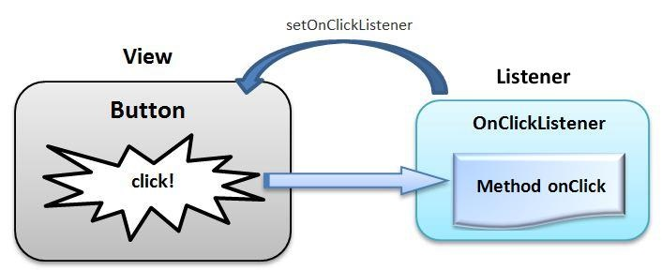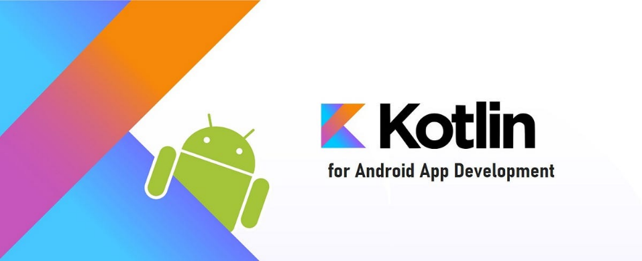

REFERENCES:

(http://scielo.org/), S. (no date) *Scientific Electronic Library Online*, *SciELO.org*. Available at: https://www.scielo.org/ (Accessed: 09 April 2024).

*Educational apps for history lessons* (2022) *Promethean World*. Available at: https://www.prometheanworld.com/gb/resource-centre/blogs/educational-apps-for-history-lessons/ (Accessed: 09 April 2024).

*Kotlin programming language* (no date) *Kotlin*. Available at: https://kotlinlang.org/ (Accessed: 09 April 2024).

*Learn to code* (no date) *W3Schools Online Web Tutorials*. Available at: https://www.w3schools.com/ (Accessed: 09 April 2024).

*Let’s build from here* (no date) *GitHub*. Available at: https://github.com/ (Accessed: 09 April 2024).